DESIGN:

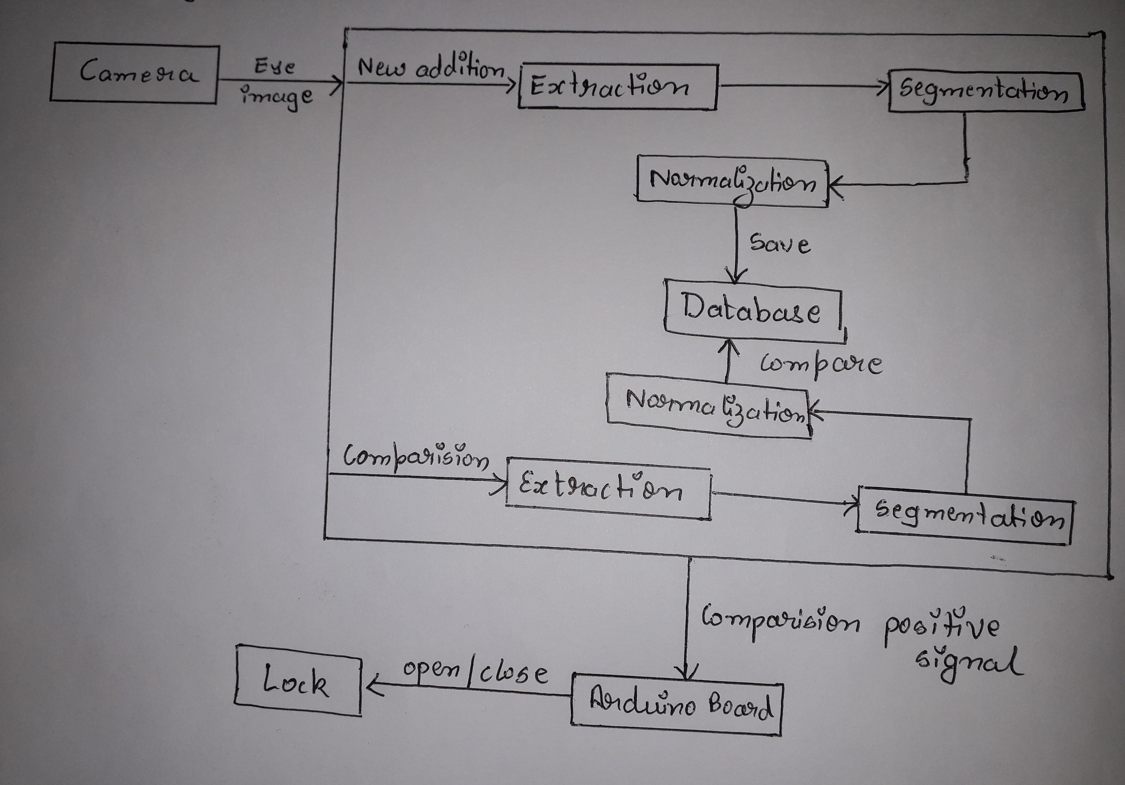
MODULES:

1) Sensor module which acquires the biometric data.

2) Feature extraction module where the acquired data is processed to extract feature vectors.

3) Matching module where feature vectors are compared.

4) Decision-making module in which the user's identity is established or a claimed identity is accepted or rejected.

